REPORT for Project 04: Classification

CSE 537: Artificial Intelligence

Prasidh Srikanth(109294122) and Ritwik Das(109068226)

# Question 3: Find high odds features

We have implemented the high odds features in naivebayes.py which returns a list of 100 features with highest odds ratios for label1 (3) over label2(6). We ran the following command:

python dataClassifier.py -a -d digits -c naiveBayes -o -1 3 -2 6

We looked at the result which closely resembled the picture in **‘a’** and have returned the same in answers.py.

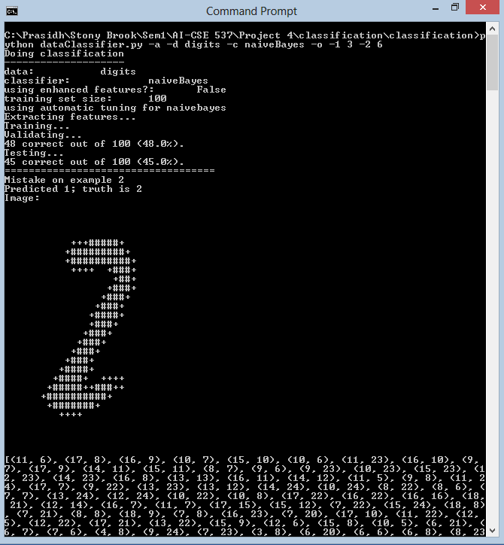

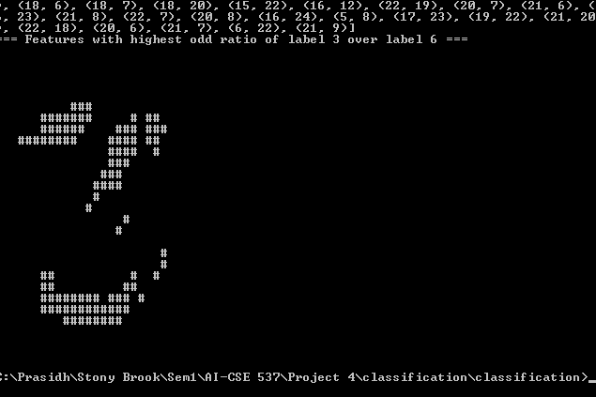

**OUTPUT:**

C:\Prasidh\Stony Brook\Sem1\AI-CSE 537\Project 4\classification\classification>p

ython dataClassifier.py -a -d digits -c naiveBayes -o -1 3 -2 6

Doing classification

--------------------

data: digits

classifier: naiveBayes

using enhanced features?: False

training set size: 100

using automatic tuning for naivebayes

Extracting features...

Training...

Validating...

48 correct out of 100 (48.0%).

Testing...

45 correct out of 100 (45.0%).

===================================

Mistake on example 2

Predicted 1; truth is 2

Image:

+++#####+

+#########+

+##########+

++++ +###+

+##+

+###+

+###+

+###+

+####+

+###+

+###+

+###+

+###+

+###+

+####+

+####+ ++++

+#####++###++

+##########+

+#######+

++++

[(11, 6), (17, 8), (16, 9), (10, 7), (15, 10), (10, 6), (11, 23), (16, 10), (9,

7), (17, 9), (14, 11), (15, 11), (8, 7), (9, 6), (9, 23), (10, 23), (15, 23), (1

2, 23), (14, 23), (16, 8), (13, 13), (16, 11), (14, 12), (11, 5), (9, 8), (11, 2

4), (17, 7), (9, 22), (13, 23), (13, 12), (14, 24), (10, 24), (8, 22), (8, 6), (

7, 7), (13, 24), (12, 24), (10, 22), (10, 8), (17, 22), (16, 22), (16, 16), (18,

21), (12, 14), (16, 7), (11, 7), (17, 15), (15, 12), (7, 22), (15, 24), (18, 8)

, (7, 21), (8, 8), (18, 9), (7, 8), (16, 23), (7, 20), (17, 10), (11, 22), (12,

5), (12, 22), (17, 21), (13, 22), (15, 9), (12, 6), (15, 8), (10, 5), (6, 21), (

6, 7), (7, 6), (4, 8), (9, 24), (7, 23), (3, 8), (6, 20), (6, 6), (6, 8), (8, 23

), (18, 6), (18, 7), (18, 20), (15, 22), (16, 12), (22, 19), (20, 7), (21, 6), (

6, 23), (21, 8), (22, 7), (20, 8), (16, 24), (5, 8), (17, 23), (19, 22), (21, 20

), (22, 18), (20, 6), (21, 7), (6, 22), (21, 9)]

=== Features with highest odd ratio of label 3 over label 6 ===

###

####### # ##

###### ### ###

######## #### ##

#### #

###

###

####

#

#

#

#

#

#

## # #

## ##

######## ### #

############

########

C:\Prasidh\Stony Brook\Sem1\AI-CSE 537\Project 4\classification\classification>